SQL Introduction 1
SQL Data Definition Language (DDL) 1
SQL Data Manipulation Language (DML) 1
Datatypes 2
SQL Introductory Exercise 2
MySQL 2
Installing MySQL 2
Create Database 5
Creating Tables 5
Viewing the Structure of your Tables 6
Inserting Data 6
Viewing data 8
SELECT 8
All 8
WHERE 8
DISTINCT 9
ORDER BY 9
Exercises: 10

SQL Introduction
This is a very very light introduction to SQL.

Structured Query Language (SQL – pronounced like sequel) is a standard language that enables the creation and maintenance of data structures as well as the viewing and modification of data within them.

Most variations of SQL are very similar however each vendor such as Oracle or DB2 uses their own variation of SQL so some commands that work for one DBMS may not work on another.

SQL Data Definition Language (DDL)
Enables the creation, alternation, and deletion of tables, views, and indices. DDL statements include
CREATE, ALTER, DROP

SQL Data Manipulation Language (DML)
Enables insertion, updates, viewing, and deletion of data. Common commands include:
INSERT, SELECT, UPDATE, DELETE

Datatypes
Creating a table requires you to have an understanding of datatypes. Datatypes are the set format for an attribute. For example, the data format may be integer for whole numbers, varchar for alpha numeric numbers, float for fractions.

Datatypes are used to enforce:
- storage efficiency
- data integrity
- logical relationships

Here are some common datatypes. Variations of these will exist in different databases.
Datatype | Description | Example:
INT | Numeric entry | id INT
VARCHAR(n) | Text string of characters up to n with a maximim of 255 characters | name VARCHAR(20)
CHAR(n) | Text string with specific number (n) of characters. If the number of characters is less than 'n' then is padded by spaces (spaces are removed when data is retrieved). 255 Maximum. | address CHAR(30)
TEXT | Holds between 255 - 65535 characters | philosophy TEXT
DATE | The date stored in the format YYYY-MM-DD | dob DATE
TIME | The time stored in the format HH:MM:SS | tob TIME

SQL Introductory Exercise
This exercise will use hands on examples to introduce SQL scripting. MySQL will be used as the database for running the SQL.

MySQL
MySQL is probably the most common database that is used for web development. It is popular because it is light weight and it is free. Much like SQL Server or Oracle, it too permits use of SQL as does any mainstream relational database.

Installing MySQL
To download MySQL go to:
http://dev.mysql.com/downloads/mysql/5.0.html#win32

Download the version with the installer.

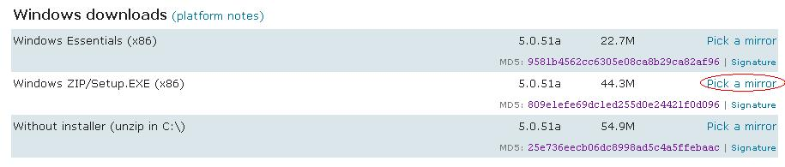

Once the package is downloaded, unzip it and double click the setup file to start the install. Advance through the next screens choosing all defaults until you reach the dialog for configuring your MySQL Server instance. Select the following items so MySQL server will launch when your computer starts and to enable easier use of the MySQL client:
- Install as Windows Service
- Launch the MySQL Server automatically
- Include Bin Directory in Windows Path
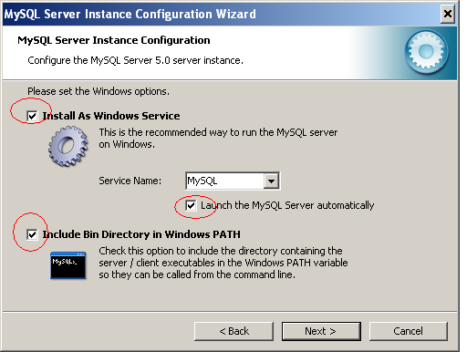

Enter your password. I suggest the word “password” so you can remember it.
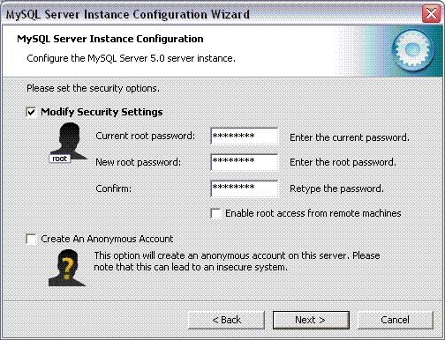

Continue to advance through the default install screens until you reach the end.

To launch MySQL client go to Start | All Programs | MySQL | MySQL Server 5.0 | MySQL Command Line Client. When prompted type your password that was created during setup and press Enter.

Create Database
To create a database in MySQL, type CREATE DATABASE mydb; and then press enter. To modify the contents or structure of your database type USE mydb;
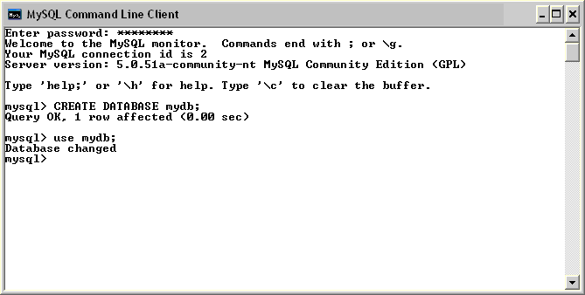

Now we can start entering SQL to create, update, and modify our tables and to view our data.

Creating Tables
The syntax for creating a table is as follows:

CREATE TABLE <table_name> (
field1 datatype,
field2 datatype,
etc......
);

The command statement will not be executed until you use a semi-colon. In this statement the table name, field names, and data types for each field are specified.

Try running this command in your MySQL client to build a table which stores CD data and has the cdID as the primary key.
CREATE TABLE cds
( cdID INT(3) primary key,
artist VARCHAR(20),
title VARCHAR(30),
year INT(4),
label VARCHAR(20),
bought DATE );

The MySQL client should return a message that indicates you have been successful.

Viewing the Structure of your Tables
You can check that you have created the table correctly by issuing a 'describe' command. When you enter describe and the table name it will show the fields, the data type, whether nulls are permitted, if the primary key

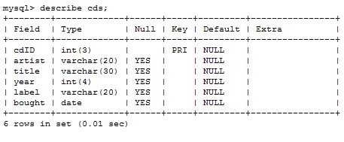

Inserting Data
The SQL statement to INSERT data is again fairly straight forward once you get used to the syntax. The basic syntax for the INSERT statement is as follows.

INSERT INTO <table_name>
VALUES (
value1,
value2,
etc......
)

This will work fine if you are inserting data into every field in a row. However if you only want to insert data into a subset fields (columns) you will need:
- to specify the field names in the INSERT statement
- to ensure columns where no data is inserted permit NULL values.
Here is another variation of INSERT syntax which inserts a subset of values.

INSERT INTO <table_name> (
column1,
column2,
....
) VALUES (
value1,
value2,
....
)

Try running this command in your MySQL client to build a table which stores CD data:
INSERT INTO cds
(cdID, artist, title, year, label, bought)
VALUES
( 1,
'jamiroquai',
'A Funk Odyssey',
2001,
'Sony Soho2',
'2001-09-01');

If successful you should see the following data the message:
Query OK, row affected (0.02 sec)

Try entering another record with slightly different syntax. This variation works without specifying columns because all columns are present:
INSERT INTO cds VALUES (
2,
'U2',
'Unforgettable Fire',
1985,
'Island Records’,
'2001-09-01');

Once again you should see the following data the message:
Query OK, row affected (0.02 sec)
Now try inserting two more records by running the following two commands:
INSERT INTO cds VALUES (
3, 'U2', 'Joshua Tree', 1987, 'Island Records', '2003-09-14');

INSERT INTO cds VALUES (
4, 'ABC', 'ABC', 1984, 'Virgin Records', '2003-09-14');

Viewing data
Data is viewed through a query.

SELECT
SELECT commands permit viewing of data. Even though MySQL tells us that this our data inserts have worked, we can check for ourselves by issuing a SELECT query. Various operators can be used to filter and organize the data and these will be discussed in more detail later.

All
Viewing is done with with the select statement. * retrieves all records. If you run this command you will see all records.
SELECT * FROM cds;

The results will be as follows:
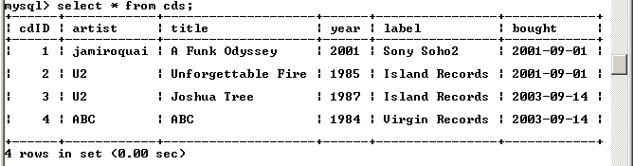

Selecting a Subset of fields
You can retrieve a subset of fields by specifying which fields are needed rather than the entire record. The following command:

SELECT artist, title FROM cds;

Will retrieve the all artists and corresponding titles:
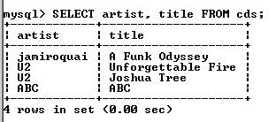

WHERE
The WHERE clause is used to filter records so only a sub-selection is drawn from the database.

Try typing the following to only retrieve U2 records:
SELECT * from cds WHERE artist = “U2”;

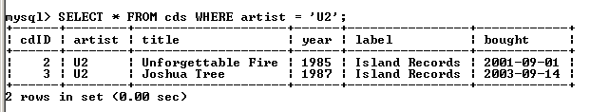

DISTINCT
Distinct retrieves one instance of a field only. If you try running this command:
SELECT Distinct artist FROM cds;

The result will be:
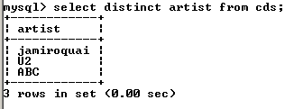

ORDER BY
ORDER BY controls the sequence of results. For example to display all the data from the 'cds' table ordered alphabetically by artist we would issue this command.

SELECT * FROM cds ORDER BY cds.artist;

The output from this command is:
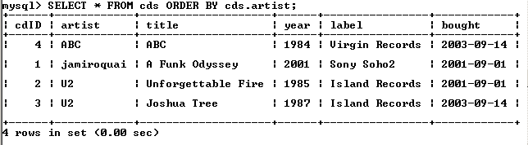

Exercises:
- Install MySQL Server at home. Add your own hit record. Make up a title for your record and use your name as the artist.
- Create a select statement to retrieve all records and order them by artist name. Include all fields except the bought date. Run the statement at the command line.
- Take a screenshot of your result from #2 and submit it to your individual discussion folder. In the subject line label it SQLIntroduction. Label it MySQL.

